Overview
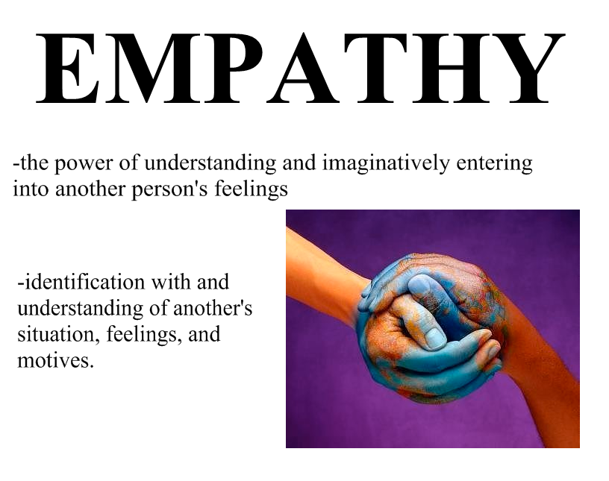
The study of a country’s history and evolution requires more than the memorization of dates, names and facts. Historians need to develop a deep understanding of the confounding circumstances of events, including people, places, cultures, politics and many other factors. Coming to know why things happened the way they did is as important as knowing what happened and when. As Jill Lepore said, “The study of our history requires investigation, imagination, empathy and respect (The Whites of Their Eyes: The Tea Party's Revolution and the Battle over American History, 2010)
When we take the opportunity to learn about Canada’s history, we can begin to understand and appreciate the struggles of the people who helped shaped (delete d) Canada’s identity today. As Frederick Douglas said, “Without a struggle, there can be no progress” (1857).
Design Rationale
Canada has a reputation of being a compassionate and caring country. We have a history of being global peacekeepers, and our prime minister, Lester Pearson won the Nobel Peace Prize in 1957 for his efforts.
In the recent humanitarian crisis in Syria, Canadians have stepped up to welcome refugees and incorporate them into our communities. Canadians pride themselves in the inclusion of others and we socially and legally respect of (?) diversity. However, we do not have an unblemished history, especially in our treatment and inclusion of our Aboriginal Canadians.

Problem Scenario
Your team has been selected by the federal Arts and Heritage organization to design an interactive, 3 dimensional depiction of a historical event that involved an injustice to our Aboriginal Canadians. This depiction should help viewers to understand the what, where, when, and why of the event. Further, it should help them to gain empathy for those impacted by the event.
Your depiction must:
- be a small scale model (Bold) that captures the feelings and thoughts of one of the people or groups of people involved in an historical event
- communicate clearly this perspective to an audience
- have some degree of interaction
- demonstrate your knowledge of the historical event and the context in which it occurred

Success Will Be Determined By
- Ability of your depiction to capture the perspective (thoughts & feelings) of the group impacted by the historical event
- Alignment of your depiction with the design sketch
- Degree to which the event is represented in detail
- Degree to which your depiction is visually appealing (craftsmanship, attention to detail) to warrant the placement in a museum
- Purposeful use of colour / general aesthetics to capture mood and feeling
- Uniqueness and accuracy of your depiction and the degree to which portrays a historical event

Parameters
- You may use the tools provided to you in the classroom/pantry
- You must prepare a group display which includes:
- A monument plaque that explains the connections between the represented perspective and the historical event
- Your team names
- Reflection on the design process that you and your team has just completed
- Your design thinking sketches
- You must use some of all of the items in the Participant Group Kit in some way

Suggested Grade Level
- Elementary through to secondary school
- Possibly primary grades with adult assistance

Suggested Subject Area
- Citizenship – including school culture / community
- Social Studies

A scale model means that your model may be much smaller or larger than the actual, final product.

